OPENSPACE PROJECT
Capture Upload and Secret Credentials Management
Visual Process and Architecture Brief
A diagram-led explanation of the local MVP, OpenSpace private API workflow, secure credential handling.

Prepared for the OpenSpace technical discussion | 1 September 2026

System flow
From camera file to the final OpenSpace viewer
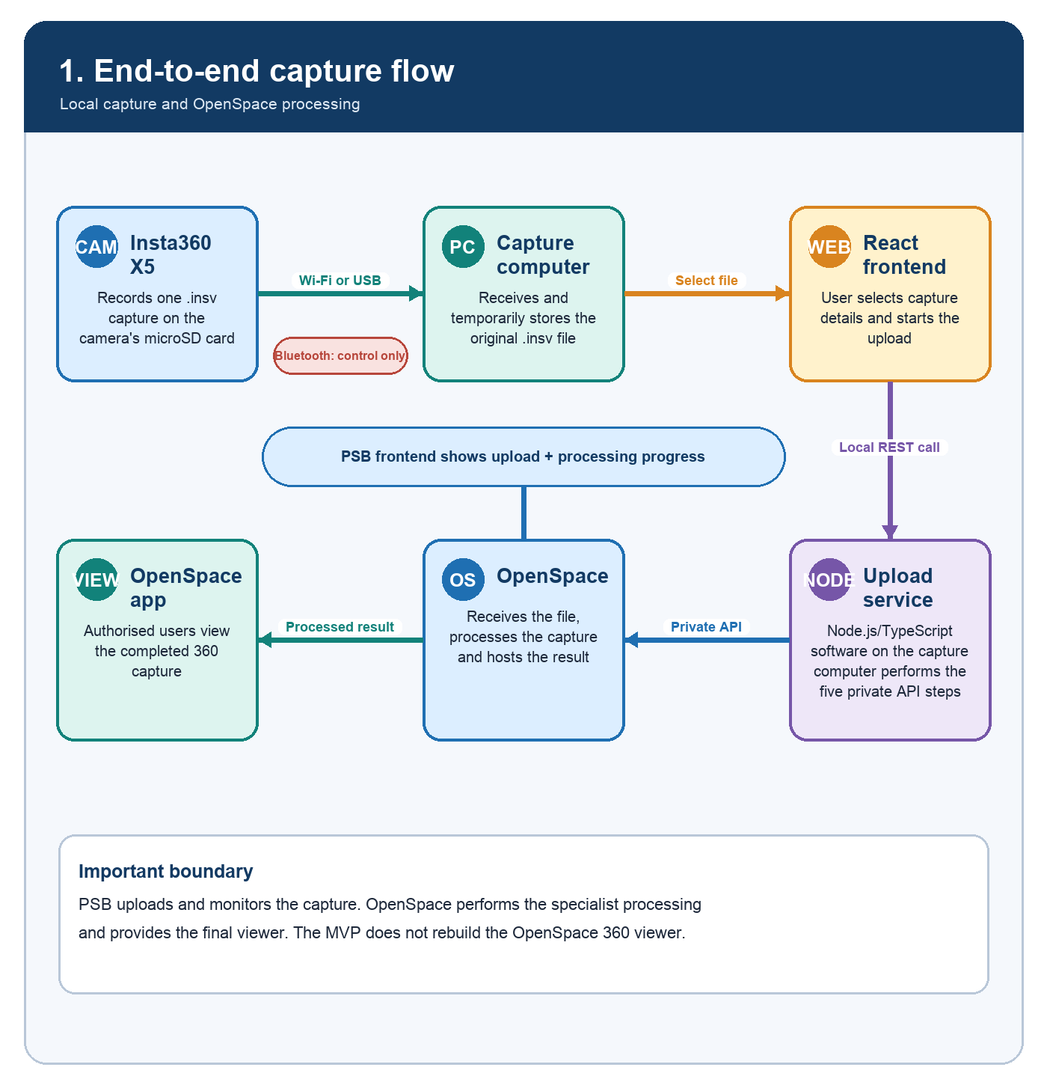
Explanation. The camera creates an INSV file. The capture computer stores it temporarily, and the local Node.js service performs the OpenSpace private API workflow while React displays progress.
Implementation note. The upload service streams an existing file; it is not a live camera stream. OpenSpace remains responsible for processing and final viewing.
Source: OpenSpace Capture Upload API - Private Integration (supplied to the PSB project team).

Local-first MVP
The first implementation uses a local React app and computer-based upload service
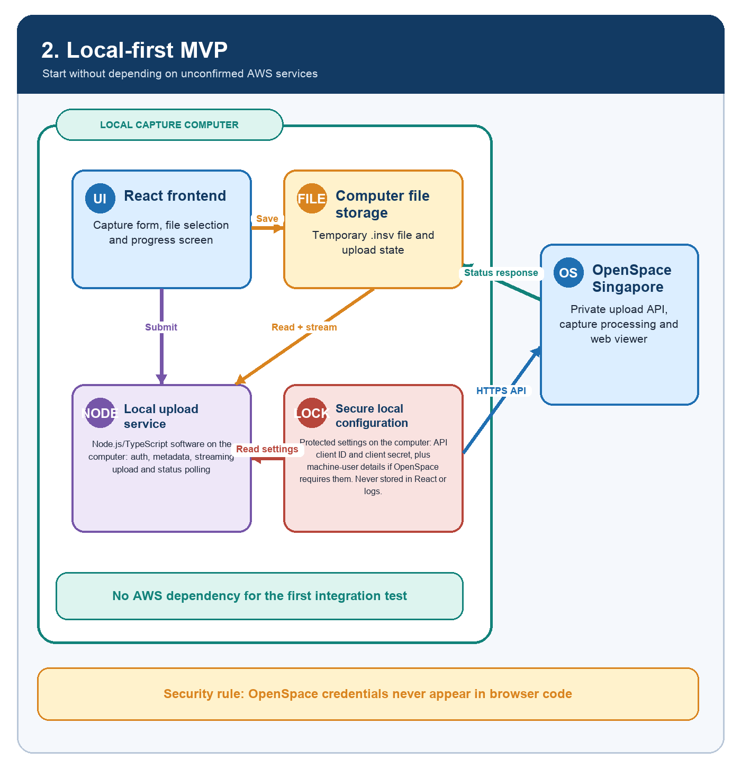
Explanation. React provides the user interface. A separate Node.js/TypeScript service on the same computer protects credentials, reads the file and calls OpenSpace.
Implementation note. The 1Password item appears to contain an API client ID and client secret. OpenSpace should confirm the token flow, required scopes and whether a separate machine-user identity is also required. Credentials must never be embedded in React browser code.
Source: OpenSpace Capture Upload API - Private Integration.

Five API steps
The exact workflow described in the supplied private integration document
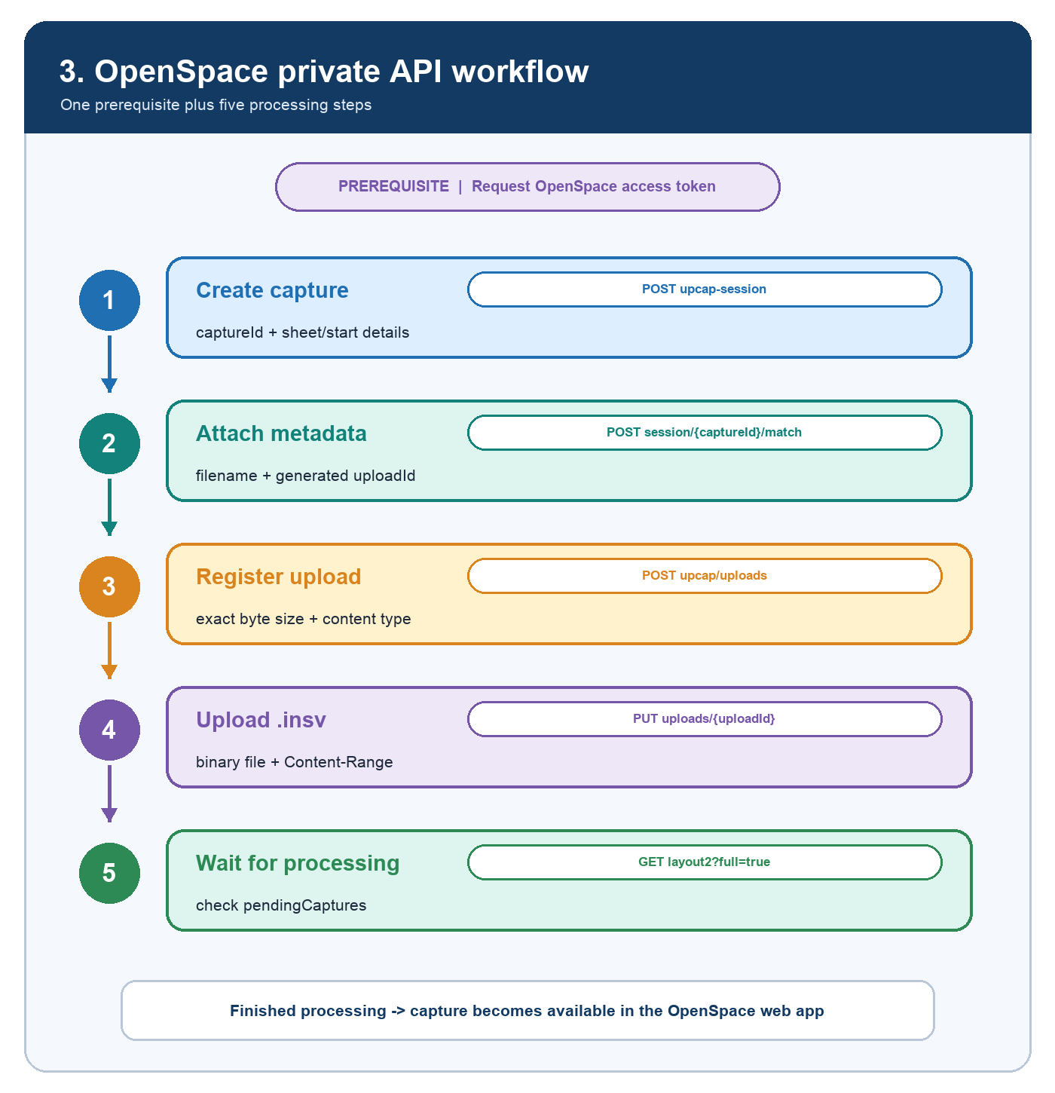
Explanation. After obtaining an access token, the uploader creates the capture, attaches metadata, registers the file, uploads the binary and monitors processing.
Implementation note. Each capture should have a local job record so failed steps can be diagnosed and retried without confusing the user.
Source: OpenSpace Capture Upload API - Private Integration (supplied to the PSB project team).

Progress and status
What users can see in the PSB frontend
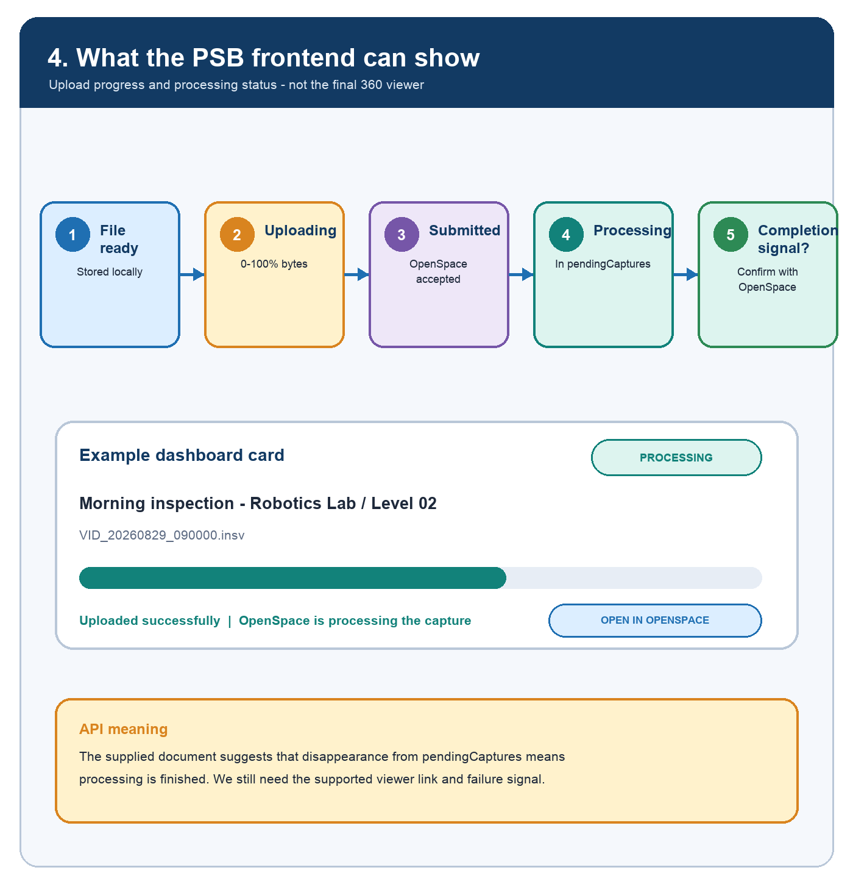
Explanation. The PSB dashboard can show local file readiness, byte-upload progress, submission and OpenSpace processing status. The completed visual is opened in OpenSpace.
Implementation note. The team should confirm the supported success and failure signals, and how the frontend obtains the final OpenSpace capture/viewer link or identifier.
Source: OpenSpace Capture Upload API - Private Integration (supplied to the PSB project team).

Local secret management
How authorised integration developers run Node.js without copying secrets into the project
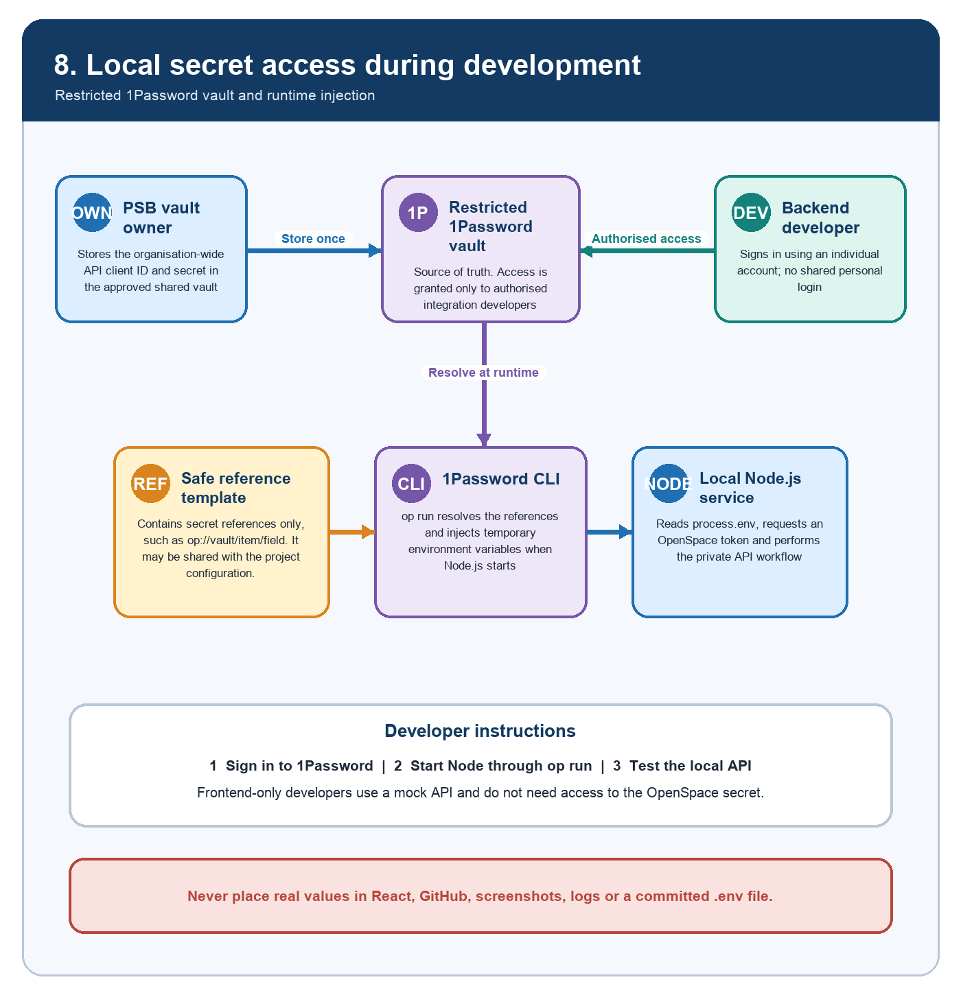
Explanation. For the local MVP, the approved 1Password vault remains the source of truth. An authorised developer signs in personally, and the 1Password CLI injects the API client ID and secret into the Node.js process only while it is running.
Implementation note. Use a secret-reference template and start Node.js through op run. Grant vault access only to backend/integration developers; frontend-only developers should use a mock local API. Do not use temporary share links as the long-term team source of truth.
Reference: 1Password Developer Documentation - Load secrets into scripts.

Meeting questions
Clarifications required before finalising the OpenSpace integration
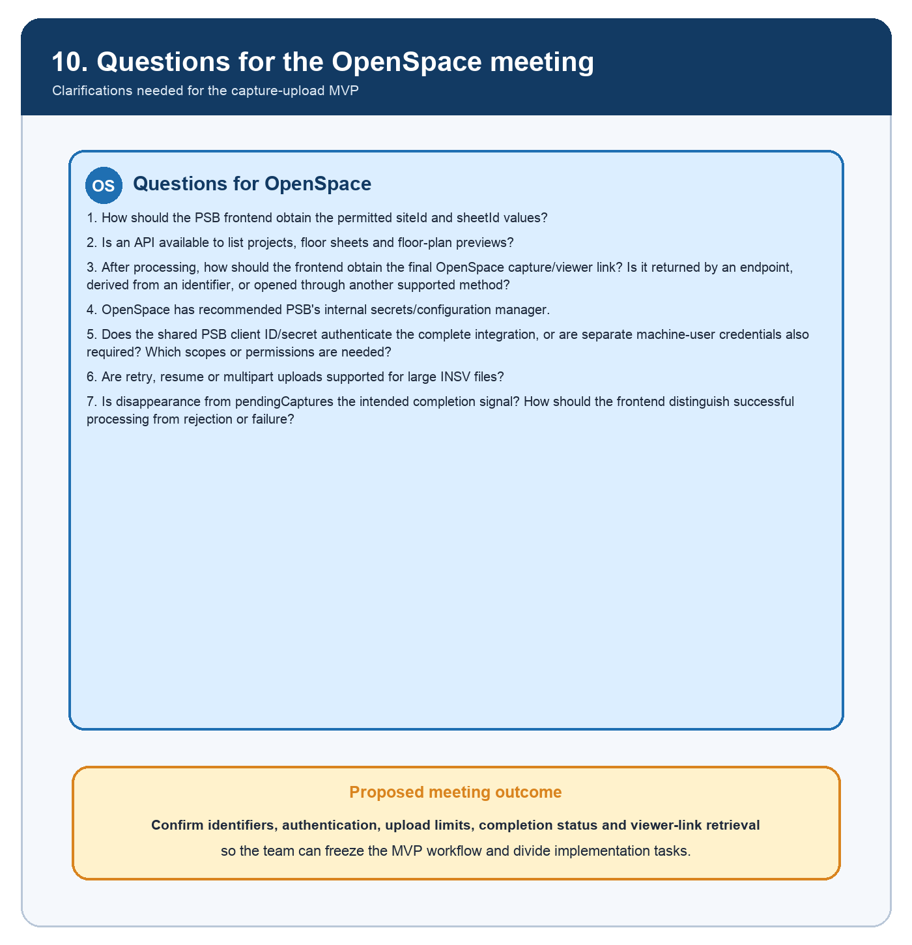
Explanation. The revised questions focus on OpenSpace identifiers, API authentication, credential protection, large-file upload behaviour, processing completion and final viewer-link retrieval.
Implementation note. Answers should be recorded as architecture decisions before the team freezes the MVP and assigns implementation ownership.
Discussion draft for the OpenSpace technical review.

